
ENGREG HIGH SCHOOL
24, Bankole Street, Pedro, Shomolu, Lagos
WEEK: 5 FIRST TERM SESSION: 2024/2025
SUBJECT: COMPUTER STUDIES |  | TOPIC: DATABASE
CLASS: JSS 3 | DATE: 7th to 11th October, 2024 | REFERENCE BOOKS: New Computer Studies for JSS 3 by J.O.E Otuka et al Pages 15-18  WABP ICT for JSS 3 by Vincent Hope et al Pages 16-19
LEARNING PURPOSE:  To provide foundational knowledge on Database, its examples and Operational Definitions. |  |  |  | LESSON PERIOD: 1  DURATION: 40 MINS
LEARNING OBJECTIVE: By the end of the lesson, students will be able to:  - Define Database  - Define DBMS  - List examples of database.  - Explain the operation definitions of Database |  |  |  | KEYWORDS: Database, Field, Data, Record, File, Primary.
PREVIOUS LEARNING: The students were taught Digital Literacy in the previous lesson. |  | INSTRUCTIONAL MATERIALS:  Interactive board, computer system, Internet
LEARNING ACTIVITIES IN STEPS:  Step 1: The teacher marks assignment and makes correction.  Step 2: The teacher asks questions on previous knowledge  Step 3: The teacher modifies students’ response and introduces the new topic  Step 4: Students would be taken through the derailed explanation of the lesson content  Step 5: Students ask questions on the content of the lesson  Step 6: Students would be evaluated based on behavioural objectives  Step 7: Students Assignments are given and notes are marked |  |  | LEARNING TIME FOR EACH STEP:  Step 1: 3mins  Step 2: 2mins  Step 3: 3mins  Step 4: 20mins  Step 5: 2mins  Step 6: 7mins  Step 7: 3mins
LEARNING SKILLS:  Critical thinking, creative thinking, communicating and leadership development |  | ACTIVITY  - Define Database  - Define DBMS  - List three examples of database.
EVALUATIVE QUESTIONS:  - Define Database  - Define DBMS  - List examples of database.  - Explain the operation definitions of Database |  | ASSIGNMENT  Explain five operation definitions of Database

DATABASE
A database is an organized collection of data stored and accessed electronically. Databases are structured in a way that allows for efficient storage, retrieval, and management of information.
A database management system (DBMS) is a software package that allows for the creation, storage, maintenance, manipulation, and retrieval of large datasets distributed over one or more files.
EXAMPLES OF DBMS
- Microsoft Access
- Dbase IV
- Oracle
- MYSQL
- FoxBASEPlus
Operational Definitions
- Data: it is defined as raw facts or unprocessed facts or known facts.
- Field: The smallest unit of data in a database. It represents a single piece of information or attribute about a record, such as "Name" or "Age."
- Record: A collection of related fields that together represent a single data entry or entity in a database.
- File: A collection of related records. In modern databases, a file is equivalent to a table that holds multiple records of the same type.
- Key: A field (or a set of fields) used to uniquely identify records in a database table. Common types include:
- Primary Key: A unique identifier for each record in a table (e.g., Employee ID).
- Foreign Key: A field in one table that links to the primary key of another table, establishing a relationship between the two tables.

ENGREG HIGH SCHOOL
24, Bankole Street, Pedro, Shomolu, Lagos
WEEK: 5 FIRST TERM SESSION: 2024/2025
SUBJECT: COMPUTER STUDIES |  | TOPIC: TYPES/FORMS OF DATABASE
CLASS: JSS 3 | DATE: 7th to 11th October, 2024 | REFERENCE BOOKS: New Computer Studies for JSS 3 by J.O.E Otuka et al Pages 15-18  WABP ICT for JSS 3 by Vincent Hope et al Pages 16-19
LEARNING PURPOSE:  To provide foundational knowledge on the forms of database, its explanation and the tables of each form. |  |  |  | LESSON PERIOD: 2  DURATION: 40 MINS
LEARNING OBJECTIVE: By the end of the lesson, students will be able to:  - List the forms of database.  - Explain the Flat file, Hierarchical, Relational and Network Database.  - Identify the tables associated with the forms of Database. |  |  |  | KEYWORDS: Database, Field, Data, Record, File, Primary, Hierarchical, Relational, Network.
PREVIOUS LEARNING: The students were taught the definition of database and its examples in the last class. |  | INSTRUCTIONAL MATERIALS:  Interactive board, computer system, Internet
LEARNING ACTIVITIES IN STEPS:  Step 1: The teacher marks assignment and makes correction.  Step 2: The teacher asks questions on previous knowledge  Step 3: The teacher modifies students’ response and introduces the new topic  Step 4: Students would be taken through the derailed explanation of the lesson content  Step 5: Students ask questions on the content of the lesson  Step 6: Students would be evaluated based on behavioural objectives  Step 7: Students Assignments are given and notes are marked |  |  | LEARNING TIME FOR EACH STEP:  Step 1: 3mins  Step 2: 2mins  Step 3: 3mins  Step 4: 20mins  Step 5: 2mins  Step 6: 7mins  Step 7: 3mins
LEARNING SKILLS:  Critical thinking, creative thinking, communicating and leadership development |  | ACTIVITY  - List the forms of database.  - Explain the Hierarchical and Network Database.
EVALUATIVE QUESTIONS:  - List the forms of database.  - Explain the Flat file, Hierarchical, Relational and Network Database.  - Identify the tables associated with the forms of Database. |  | ASSIGNMENT  Illustrate the tables associated with the four forms of Database.

TYPES/FORMS OF DATABASE
Flat File Database: A simple database structure where data is stored in a single table or file. Often used for small-scale applications.
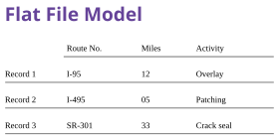
Hierarchical Database: A database where data is organized in a tree-like structure with parent-child relationships. Each parent record can have multiple child records, but each child record has only one parent.
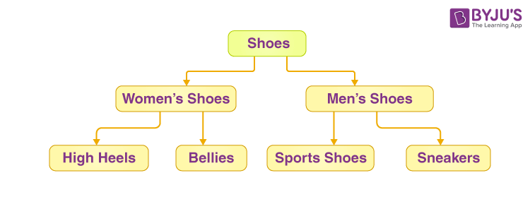
Relational Database: A more flexible database model where data is stored in tables, and relationships between tables are established using keys. This allows for more complex queries and efficient data retrieval.
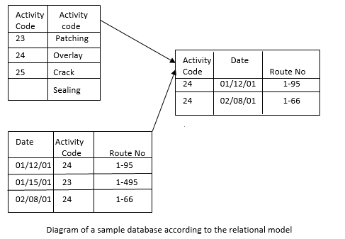
Network Database: A network database is a type of database model that allows data to be organized in a graph-like structure, where each record can have multiple parent and child records. It allows for more complex, many-to-many relationships.
